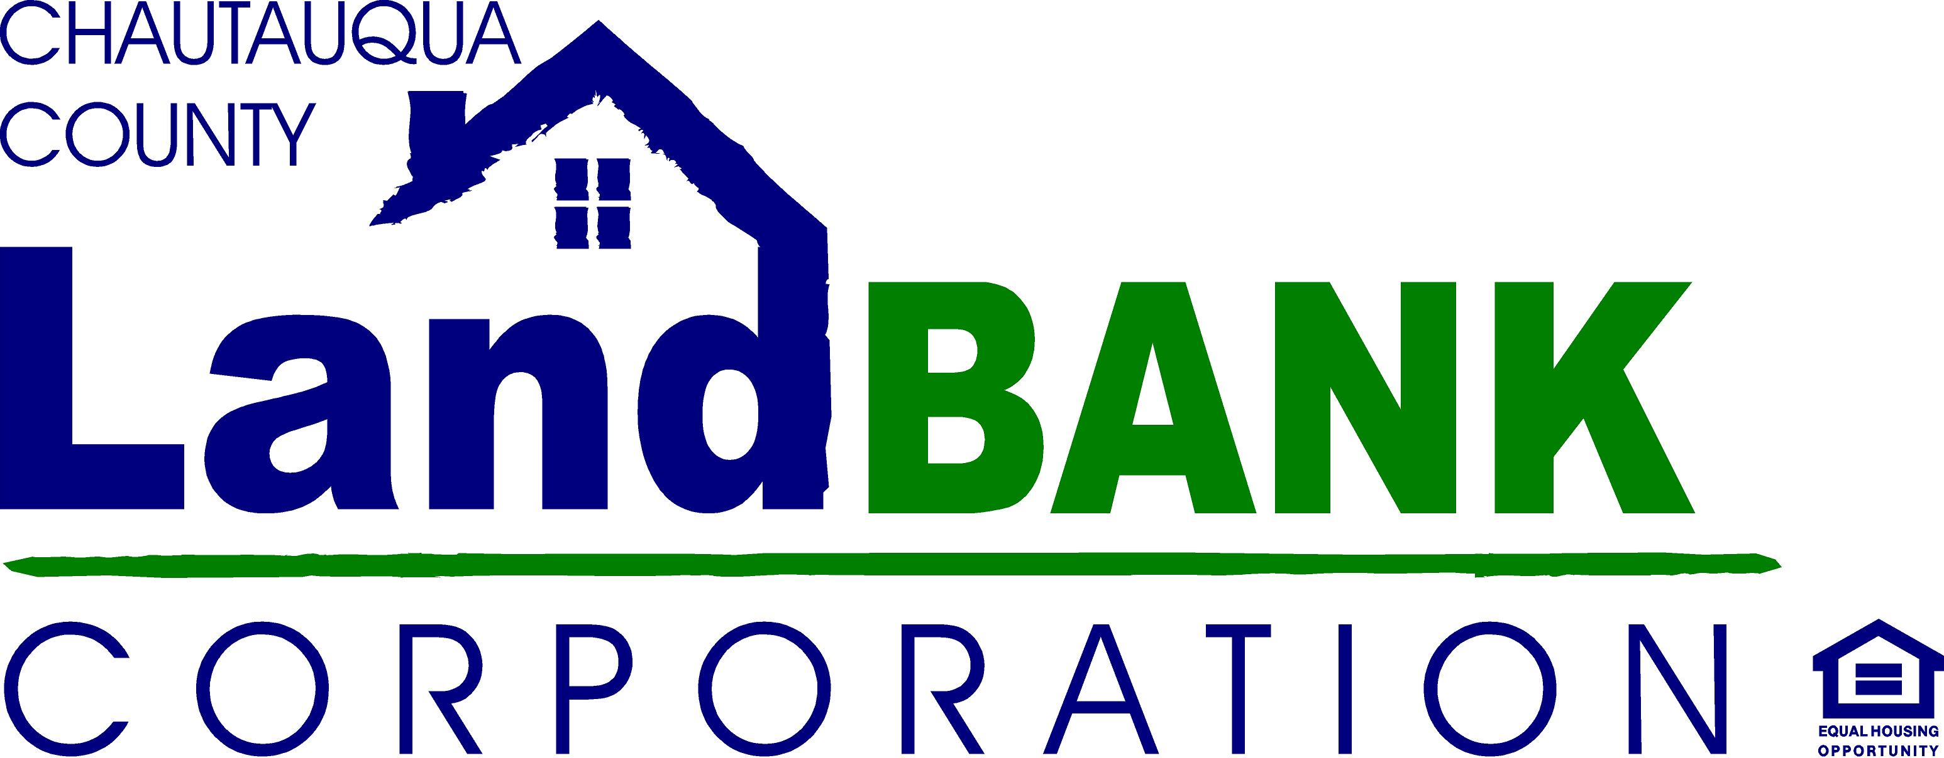

BOARD MEETING SUMMARY

DATE: April 15, 2015 LOCATION: IDA Board Room, 200 Harrison St. Ste. 300

Attendees: P. Lombardi, M. Geise, J. Caflisch, V. DeJoy, B. Carlson, P. Whitford, H. Butler, S. Butler, S. Abdella, J. Gossett
Excused: J. Hemmer, S. Neratko, Gina Paradis
Guests: none

HIGHLIGHTS

1 | Welcome: Peter L. opened the meeting at 9:05am and stated that Bill Morrell has officially resigned, which was made official by letter. Mr. Morrell stated in the letter that he spends most of the year in Florida and is not able to devote the time to the land bank that it deserves. Mr. Lombardi thanked him for his service, and advised the group to be thinking about a replacement, preferably someone with a banking background.
2 | Minutes: Minutes from the March 11th meeting of the board were approved with a motion from Jim Caflisch, seconded by Bill Carlson and was carried unanimously.
3 | Sale of Properties: Mark G. and Steve A. reviewed the Public Authorities Law regarding any properties sold by the land bank at less than fair market value, and the necessity to address the 6 conditions as prescribed by Public Authorities Law Section 2897. Mark G. proceeded to provide the details for each of the properties being sold, including 734 Main Street, Dunkirk (Tax ID # 79.19-5-58), 91 Pershing Ave, Jamestown (Tax ID# 387.13-7-5) and 4199B Bruyer Road, Stockton (Tax ID# 215.00-3-57). For each property, M. Geise provided a property description (including a property map, picture and property characteristics), appraisal, details of the proposals received, value to be received versus the fair market value, name of purchaser, and names of other parties who made offers and what those offers were. M. Geise explained that the property acquisition and disposition committee met in late February at which time it reviewed all competing proposals and made recommendations for the land bank to sell to these purchasers. Scott B. and Hugh B. asked several questions about the process for marketing the properties, soliciting proposals, reviewing proposals, and selection of top bidders, which were answered by Mr. Geise and several board members. Upon thorough review and discussion of each property, a motion to approve resolution 4-8-15-01 was made by Paul Whitford, which was seconded by Hugh Butler, and was unanimously approved by the board.
4 | Transfer of Rehab Property: Steve A. discussed the prior sale of 412 Dove Street in Dunkirk to ROM Real Estate Holdings LLC, and the fact that they purchased this property along with two other properties. It was communicated that ROM did a great job finishing the first two projects, but decided that it was not economic for them to undertake this rehab due to their work product, and that they wished to assign its development rights to another entity (Dunkirk Home Properties, LLC). Mr. Abdella reminded the board that we recently sold another property to Dunkirk Properties, and that he would be held to the same standards as ROM was (including the performance escrow). Upon further discussion by the board, the resolution was made by Jim C., seconded by Bill C., and unanimously approved by the board.
5 | Mixed Use Demolitions: Mark G. discussed the potential demolition of the Portage Inn in Westfield, and the “Cave’s Deli” building in Brocton. Mr. Geise explained that the Portage Inn demo would result in access to a parking facility/park/trail near downtown Westfield, and the Brocton project would potentially result in a small pocket park for public use. Mr. Geise explained that things were still preliminary, but that OAG had basically “approved” the Westfield project for the use of their money, which was based on a description of the project developed by the Land Bank Staff and other stakeholders.
6 | Inventory Status: Mark G. reviewed the status of properties and referenced several spreadsheets that provided the details of each property. This included properties in Cassadaga, Dunkirk, Jamestown, Westfield, and several other rural properties. A short discussion ensued to clarify the status of some of the properties.
7 | Side lot Disposition – Steve A. suggested we discuss and make a decision about the disposition of the lot next to 734 Main Street, Dunkirk, and it was recommended that it be sold by the County directly to Mr. Raimondo who is purchasing the home next door neighbor. Paul W. made a motion stating the same, which was seconded by Jeff G. and was unanimously approved.
8 | Other – Mark G. referenced the Director’s report which was included in the package, and discussed the upcoming vacant properties conference in Detroit, MI in mid-May (flier provided). It was suggested that the Land Bank pay for one of the board members to attend (along with staff), and that it be someone from the board that has not already attended a conference. Hugh B. said he might want to attend. Mr. Geise also discussed a possible change in date/time and/or location of the monthly board meetings due to a conflict, and that Gina would be contacting them regarding this issue.
9 | Adjournment – Motion by Jim C; seconded by Hugh B. Motion carried unanimously to end the meeting at 10:20 a.m.

DECISIONS
1 | Approved the sale of 3 properties (see resolution)
2 | Transfer of 412 Dove Street to Dunkirk Home Properties LLC from ROM Real Estate Holdings LLC (see resolution)
3 | Sale/Transfer of 734 Main Street, Dunkirk to Mr. Raimondo (see letter)
4 | Accept resignation from Mr. Morrell
5

ACTION ITEMS RESPONSIBLE TARGET DATE
Develop process map for acquisition/disposition process | G. Paradis | March 11, 2015
Distribute copy of standard inquiry response for Rehab4Sales program to board | G. Paradis | March 11, 2015
Develop talking points for Board members regarding LB mission and programs | G. Paradis | TBD
Prepare updated inventory of properties for annual report | G. Paradis | March 11, 2015
Complete/Distribute minutes of board meeting | G. Paradis | Completed
Schedule Presentation to Board of Realtors | G. Paradis | Completed
Secure contact info for side lots from Vince D. | G. Paradis | March 6, 2015
Assist Hugh B. with Governance Committee coordination. | G. Paradis | February 28, 2015

See Below for (Amended) Resolutions Passed at this meeting

CCLBC Board Resolutions (DRAFT VERSION WITH AMENDMENTS MADE AT MEETING)
Resolutions for Chautauqua County Land Bank Corporation Board of Directors
Meeting of February 11, 2015

Resolution Number # 2-11-15-01 Approving Appointment of Program Specialist

RESOLVED, that the Executive Director is authorized to appoint Jennifer A. Cameron, 57 Central Avenue, Fredonia, New York, to the position of Program Specialist of the Chautauqua County Land Bank Corporation effective February 12, 2015, at a salary of $2200/month, based on approximately 20 hours per week, and upon such other terms and conditions determined by the Executive Director, and to serve at his pleasure in an “at will” capacity.

Resolution Number # 2-11-15-02 Approving Sale of Land Bank Properties

WHEREAS, because it is being proposed that various Land Bank properties be sold for less than fair market value, the following information was discussed and provided to the Board and was made available to the public pursuant to Public Authorities Law § 2897:

(i) a full description of the property;
(ii) an appraisal of the fair market value of the property and other information establishing its fair market value;
(iii) a statement that the purpose and mission of the Land Bank by statute is to acquire real property that is tax delinquent, tax foreclosed, vacant, and abandoned, and dispose of such properties in a manner that will eliminate the harms and liabilities caused by such properties and that in this case, the purchaser of the property has made a comprehensive proposal to renovate the property and eliminate the blighted condition which is negatively impacting the surrounding neighborhood;
(iv) a statement of the value to be received for the property compared to the fair market value;
(v) the name of the party participating in the transfer; and
(vi) the names of other private parties who have made an offer for the property, the value offered, and the purpose for which the property was sought to be used;

therefore be it

RESOLVED, that the Chairman, Executive Director, and the Treasurer are each separately authorized to transfer the properties listed below pursuant to the proposals received from the prospective purchasers listed below, upon such other terms and conditions negotiated and approved by legal counsel; and be it further

RESOLVED, that there is no reasonable alternative to the proposed below-market transfers that would achieve the same purpose of such transfer in a manner as beneficial as the transfer being approved:

Property Address Property Tax ID Number Purchaser
28 Newton St. Dunkirk 96.07-4-43 Shong Hung Wu
71 Fairview Av., Dunkirk 79.12-1-6 Tim Odebrawlski
703 Eagle St., Dunkirk 79.18-4-75 Mr. Wong
270 Cole Av., Jamestown 387.19-1-45 M/M. Tim Desmond
255 Hazeltine, Jamestown 387.17-7-7 CHRIC
141 Beechview Av., Jamestown 370.15-3-9 M/M. Bryce Johnson

Next Meeting: March 11, 2015

